**TestNG Jar**

1. Download TestNG jar file from “http://www.java2s.com/Code/Jar/t/Downloadtestng685jar.htm”. Please refer below snapshot.

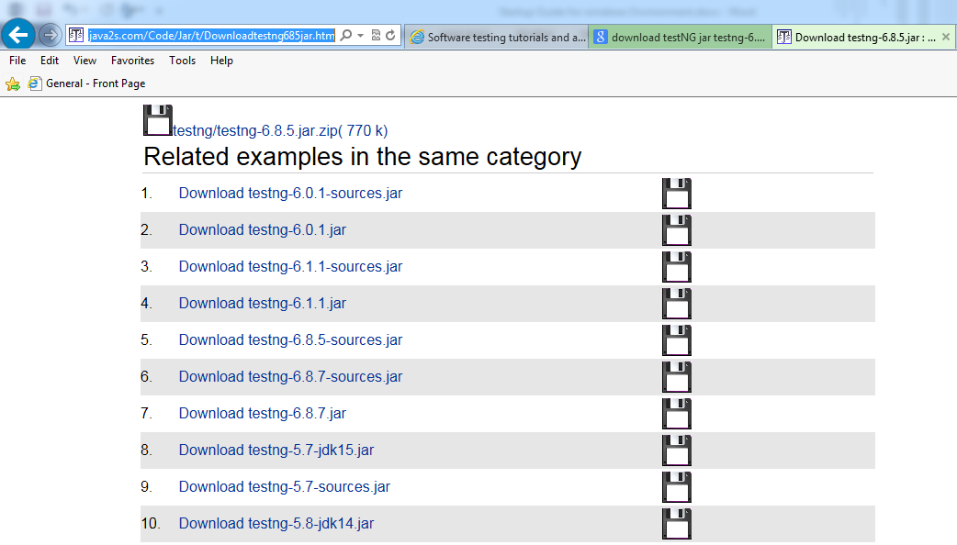

1. Add Jar files to Project
2. Select project and Right Click on Project and Select Build Path
3. Select Configure Build Path

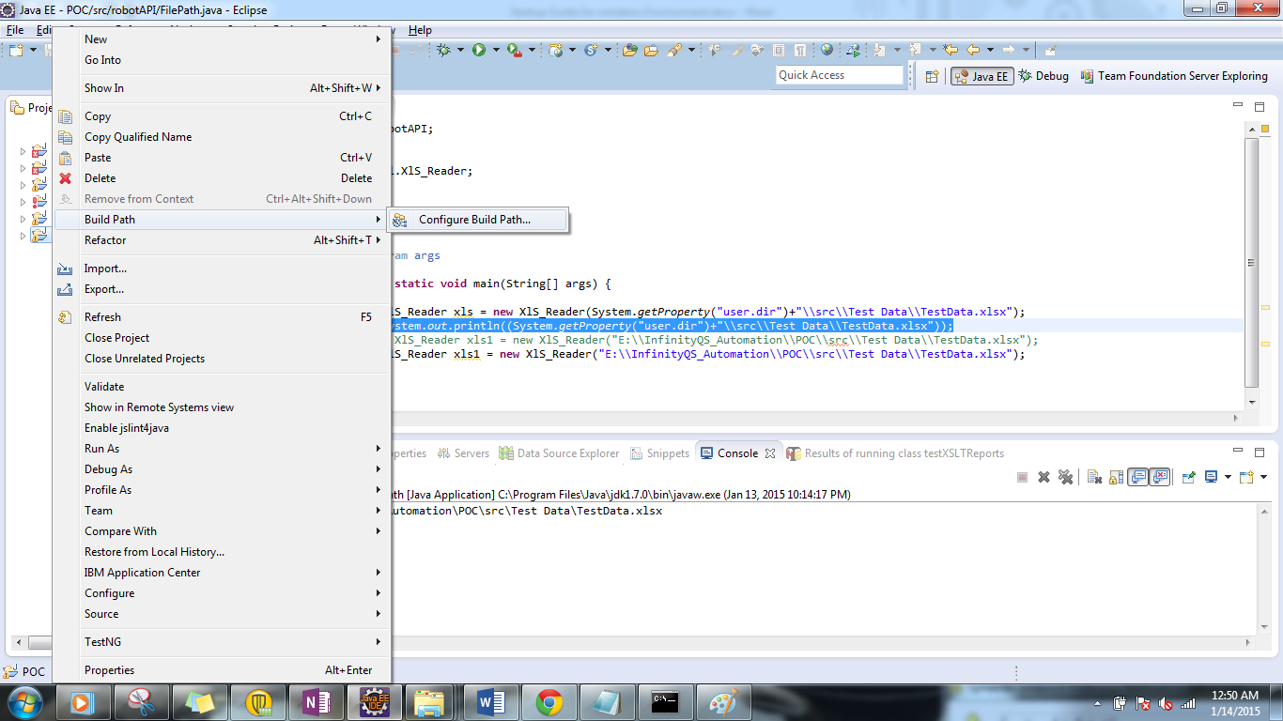

1. Library Tab in the following Dialog box.

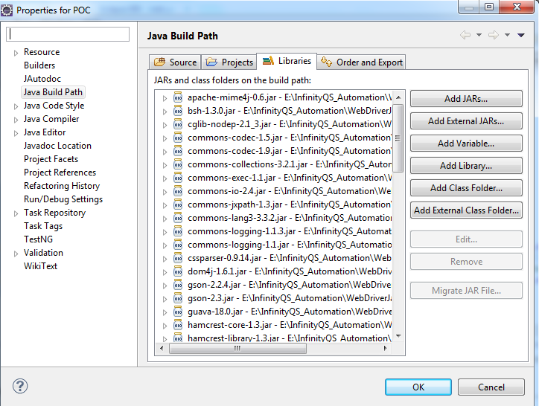

1. Click on Add External Jars.

**Install TestNG Plugin**

**Pre-requisite: Install Eclipse.**

* 1. Open Eclipse IDE.
  2. Go to Menu Bar -> Help - > Install New Software

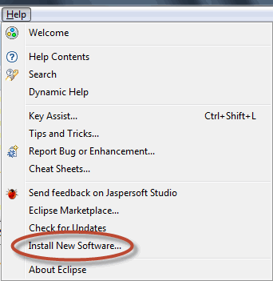

* 1. Enter the URL ([http://beust.com/eclipse/](http://beust.com/eclipse/%20title=%E2%80%9Dbeust%E2%80%9D%3E)) at Work with field and click on "Add" button.

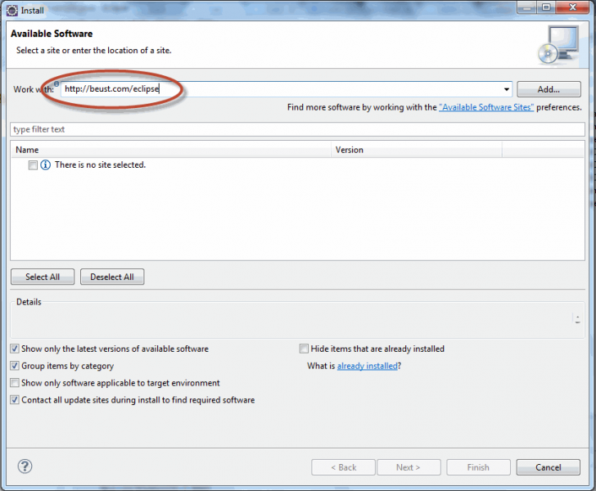

* 1. Once you click on "Add", it will display the screen, enter the Name as "TestNG".

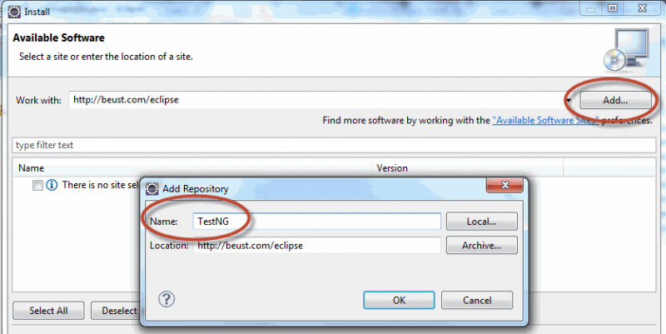

* 1. After clicking on "OK", it will scan and display the software available with the URL which you have mentioned.

Now select the checkbox at TestNG and Click on "Next" button.

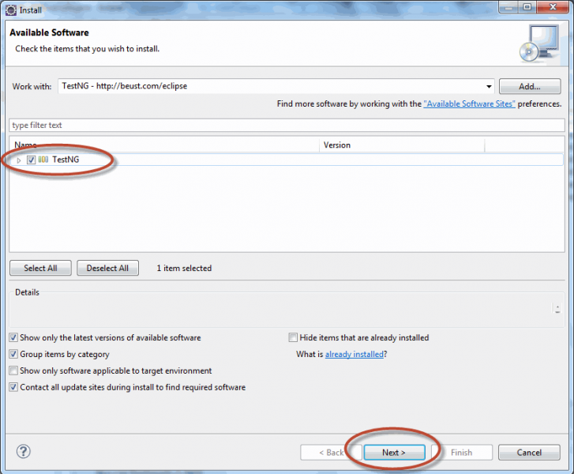

* 1. It will check for the requirement and dependencies before starting the installation.

If there is any problem with the requirements/dependencies, it will ask you to install them first before continuing with TestNG. Most of the cases it will successfully get installed nothing to worry about it.

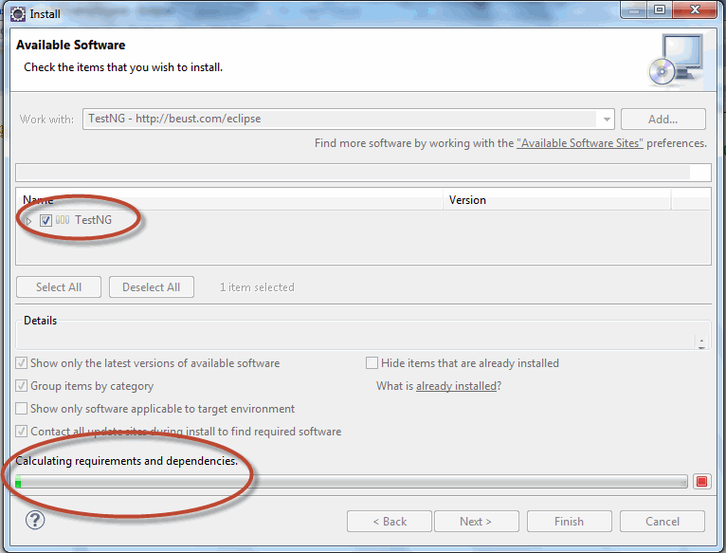

* 1. Once the above step is done, it will ask you to review the installation details. If your are ready or Ok to install TestNG, click on "Next" to continue.
  2. Accept the Terms of the license agreement and Click on "Finish" button.

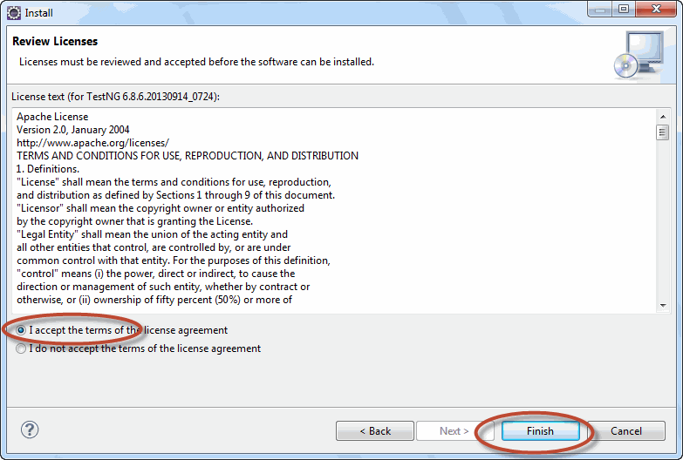

**Once the installation is done, you can check the TestNG is installed properly or Not.**

1. Go to Windows Menu bar, and Mouse Over on "Show View" and Click on "Other" at the last as in the below screen shot.

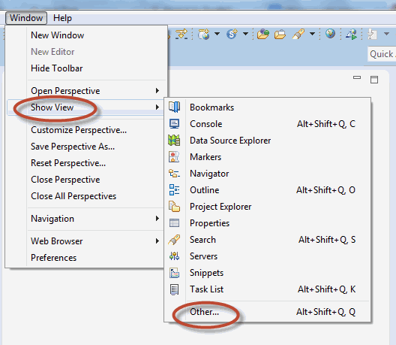

1. Expand Java folder and see if the TestNg is available as in the below screen shot.

